**KATHMANDU UNIVERSITY**

**Department of Computer Science and Engineering**

**Dhulikhel, Kavre**



**Lab Sheet 1**

**Algorithm and Complexity**

**[Course Code: COMP 314]**

**Submitted by:**

Sajag Silwal (Roll no: 48)

**Submitted to:**

Dr. Rajani Chulyadyo

Department of Computer Science and Engineering

**Submission Date:** 08-03-2022

# Implementation of Binary Search and Linear Search

## Binary Search

The implementation of binary search using recursion is given below:

Source Code:

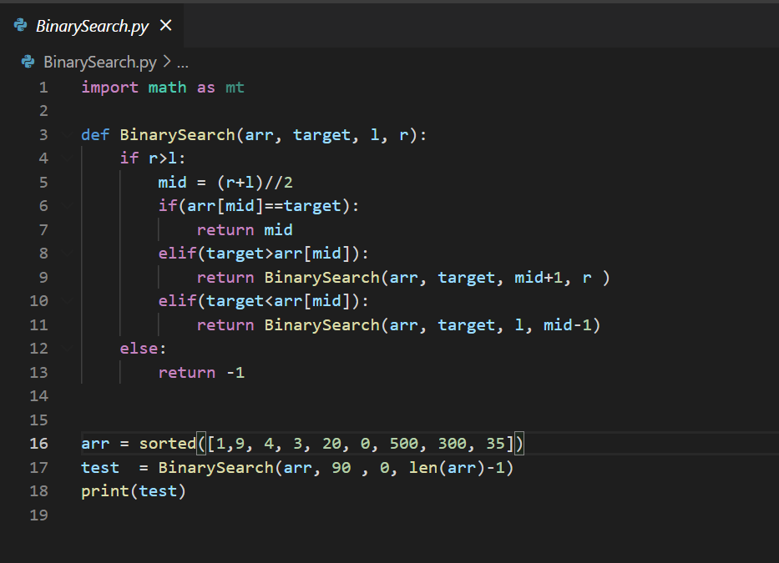

Figure 1: Recursive Implementation of binary search

## Linear Search

The implementation of Linear Search is given below

Source Code:

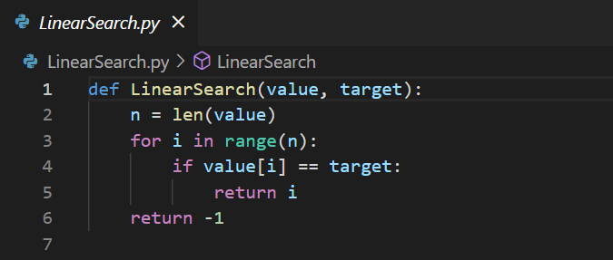

Figure 2: Iterative Implementation of Linear Search

## Test Case for Binary and Linear Search

Source Code:

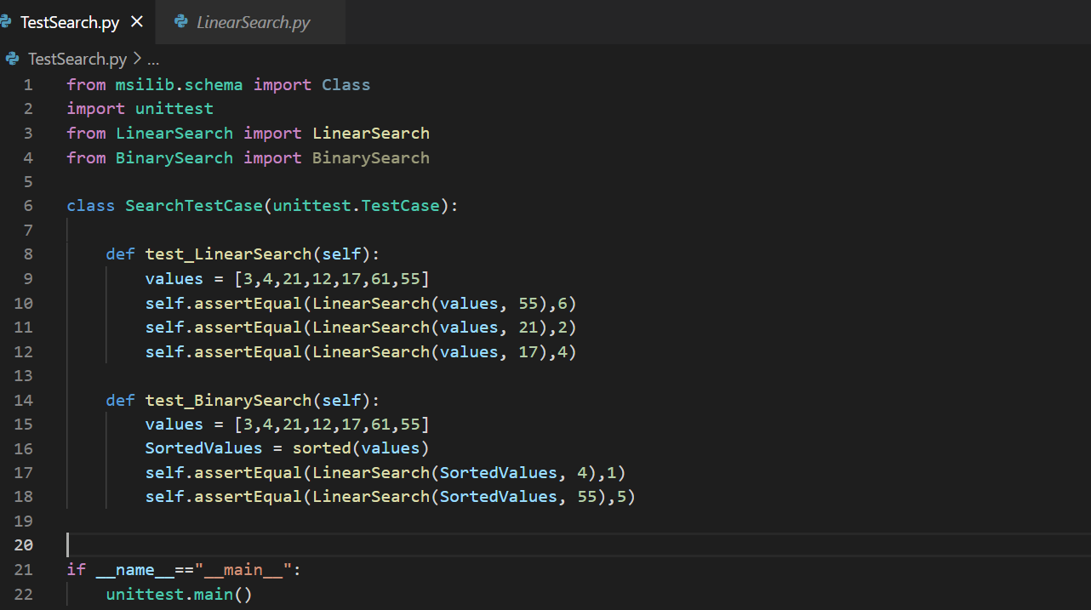

Figure 3: Source Code for Test Case

Output:

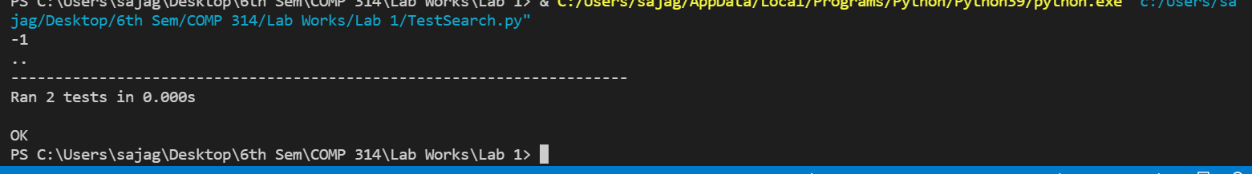

Figure 4: Output for the test case

## Plotting the graph between the length of array and execution time

After testing the algorithms, the execution times of the function calls of both linear and binary search in an array of varying sizes were recorded and plotted in the graph for best and worst-case scenarios.

Source Code:

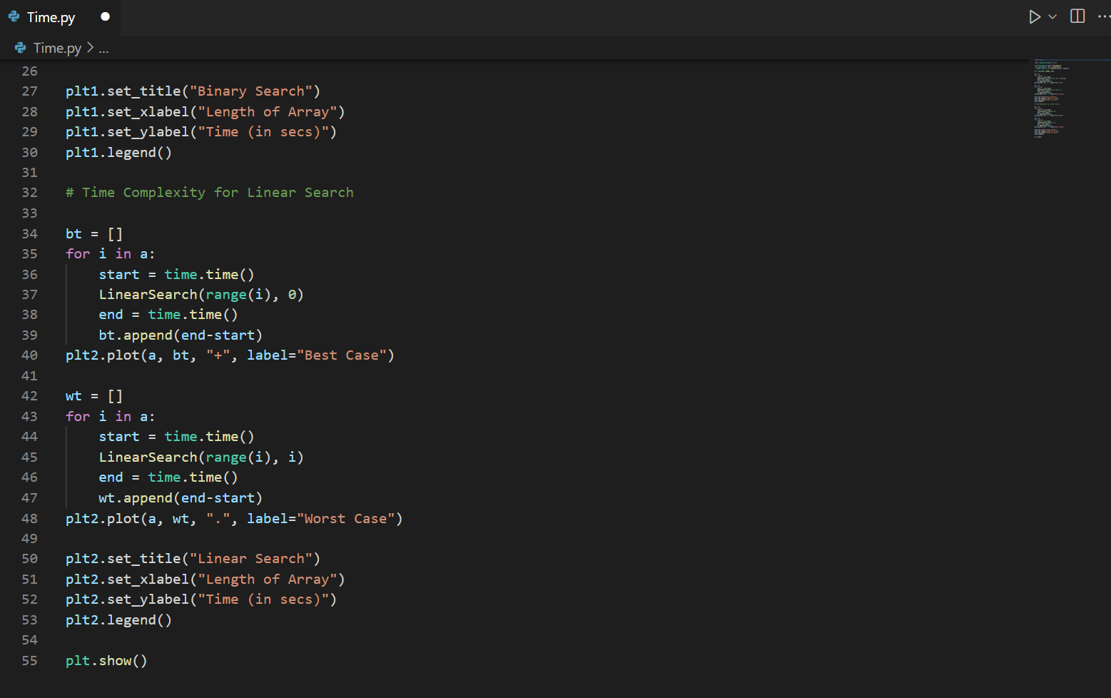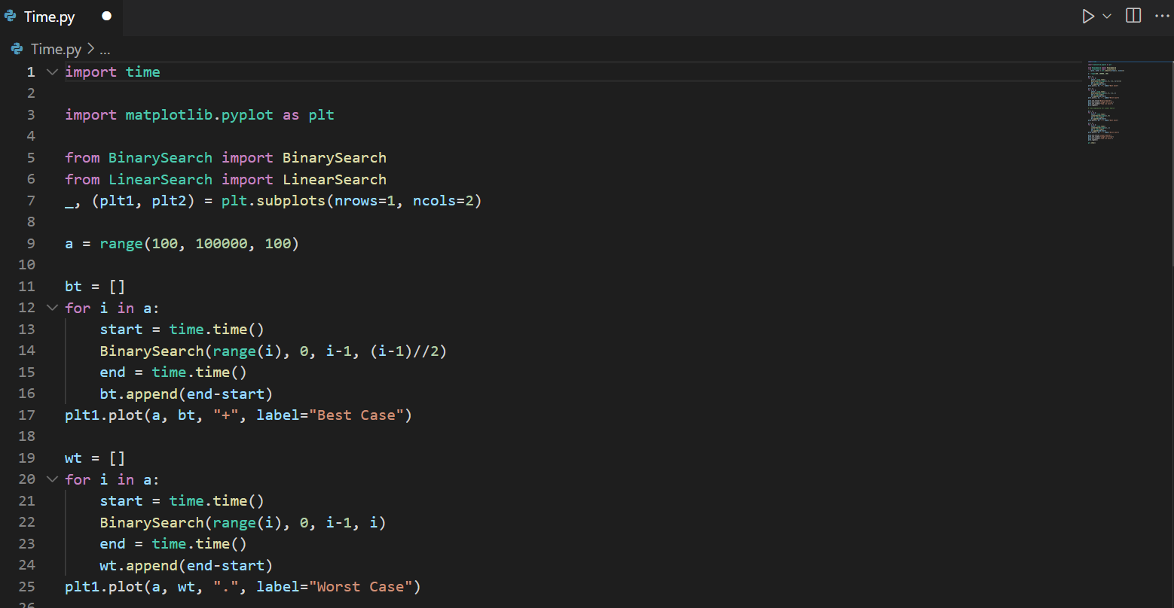

figure 5: Source Code for plotting Graph

Output:

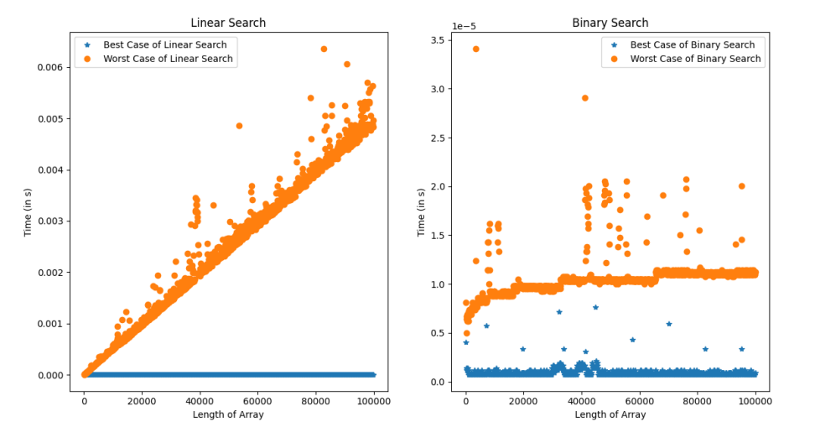

Figure 6. Graph of the length of array vs execution time for linear and binary search